

**Metaheuristic Optimization**

**Assignment 1**

**Student Id: R0018250*5***

**Name: D**heeraj **A**limchandani

**Part 1: NP-completeness**

1. Convert the formula F below into a 3SAT formula F’, find a solution to F’ and verify that this is a solution to

b. If the last digit of your student id is either 3, 4 or 5 use

**F = (w1 ∨ -w2 ∨ w3 ∨ -w4 ∨ -w5) ∧ (-w3 ∨ w4)**

**SOLUTION:**

The below is the procedure for converting the formula F into a 3SAT formula F’

Let Ci be the clause in the given SAT formula F, where i can range from i to n.

In formula F, we have two clauses and they can be represented by C1 and C2.

Where,

**C1 = (w1 ∨ -w2 ∨ w3 ∨ -w4 ∨ -w5)**

**C2 = (-w3 ∨ w4)**

The above-mentioned clauses Ci can be replaced by a conjunction of clauses in Xi.

Where,

* All Clauses in Xi­ must contain 3 literals.
* Ci is satisfiable iff constructed Xi is satisfiable and vice versa.

**Truth Table:**

|  |  |  |  |  |  |
| --- | --- | --- | --- | --- | --- |
| w1 | w2 | w3 | w4 | w5 | F |
| F | F | F | F | F | T |
| F | F | F | F | T | T |
| F | F | F | T | F | T |
| F | F | F | T | T | T |
| F | F | T | F | F | F |
| T | F | T | F | F | F |
| T | F | T | F | T | F |
| T | F | T | T | F | T |
| T | F | T | T | T | T |

Table 1

**Reduction of C1 to X1:**

C1 = (w1 ∨ -w2 ∨ w3 ∨ -w4 ∨ -w5)

Here,

w1, w2, w3, w4, w5 are literals

Let K = Number of literals in C1

Therefore K = 5

Since K > 3, we need to introduce K-3 new variables (yi1, yi2, yi3, yi4**……..** yik-3) and replace C1 with K-2 clauses to generate X1

Number of new variables = 2

C1 to be replaced with 3 clauses each having 3 literals.

Replacing C1 by a sequenceof clauses to generate X1:

**X1 =(w1 ∨ -w2 ∨ y11) ∧ (-y11 ∨ w3 ∨ y12) ∧ (-y12 ∨ -w4 ∨ -w5)**

**Reduction of C2 to X2:**

C2 = (-w3 ∨ w4)

Here,

w3, w4 are literals

Let K = Number of literals in C2

Therefore K = 2

Since K = 2, we need to introduce a new variables yi1 and replace C2 with 2 clauses to generate X2

Number of new variables = 1

C2 to be replaced with 2 clauses each having 3 literals.

Replacing C2 by a sequenceof clauses to generate X2:

**X2 =(-w3 ∨ w4 ∨ y21) ∧ (-w3 ∨ w4 ∨ -y21)**

**The 3SAT formula F’ generated is conjunction of X1 and X2:**

F’ = X1 ∧ X2

**F’** **=(w1 ∨ -w2 ∨ y11) ∧ (-y11 ∨ w3 ∨ y12) ∧ (-y12 ∨ -w4 ∨ -w5) ∧ (-w3 ∨ w4 ∨ y21) ∧ (-w3 ∨ w4 ∨ -y21)**

**Truth Table:**

|  |  |  |  |  |  |  |  |  |  |
| --- | --- | --- | --- | --- | --- | --- | --- | --- | --- |
| **w1** | **w2** | **w3** | **w4** | **w5** | **F** | **y11** | **y12** | **y21** | **F’** |
| F | F | F | F | F | T | F | F | F | T |
| F | F | F | F | T | T | F | F | F | T |
| F | F | F | T | F | T | F | F | F | T |
| F | F | F | T | T | T | F | F | F | T |
| F | F | T | F | F | F | F | F | T | F |
| T | F | T | F | F | F | F | F | T | F |
| T | F | T | F | T | F | F | F | F | F |
| T | F | T | T | F | T | F | T | F | T |
| T | F | T | T | T | T | T | F | F | T |

Table 2

2. Convert the following subclauses in your F’ to a 3Col graph

The last two clauses of F’ if the first letter of your first name is in the range A-I

**Explanation:**

In a 3Col graph, 3 special vertices are created T(true), F(false) and Y(Neutral)

If a color is assigned to each of the vertices, then:

T represents a color say Blue

F represent a color say Red

X represents a color say Yellow

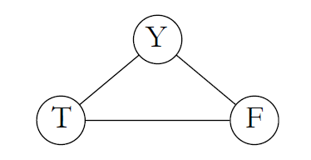 Fig 1 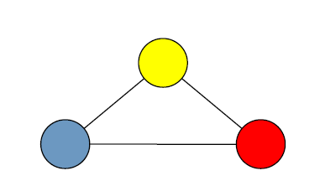

*Reference: Lecture Slides*

Generally, for the literal in the 3SAT:

* Either wi has color of T and -wi has color of F

Or

* wi has color of F and - wi has color of T

Every literal in the 3SAT should be connected to vertex Y in order to form the structure like Fig 1. Also no two adjacent vertex can have the same color

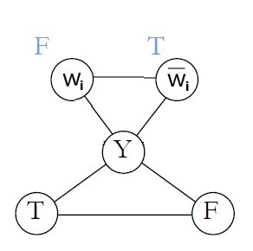

*Reference: Lecture Slides*

Fig 2

The disjunction between the literals can be solved using an OR- gadget

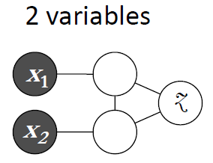 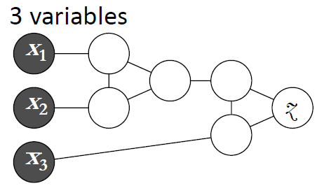

*Reference: Lecture Slides*

Fig 3

2 Variable

* Z can be colored T if either of X1 or X2 is colored T
* Z must be colored F, if X1 and X2 are colored F

3 Variable

* If at least one literal (X1, X2 orX3) is colored T, then Z can be colored T

**SOLUTION:**

Converting the below clauses to 3Col graph:

**(-w3 ∨ w4 ∨ y21) ∧ (-w3 ∨ w4 ∨ -y21)**

Where:

w3 = T, w4 = T, y21 = T

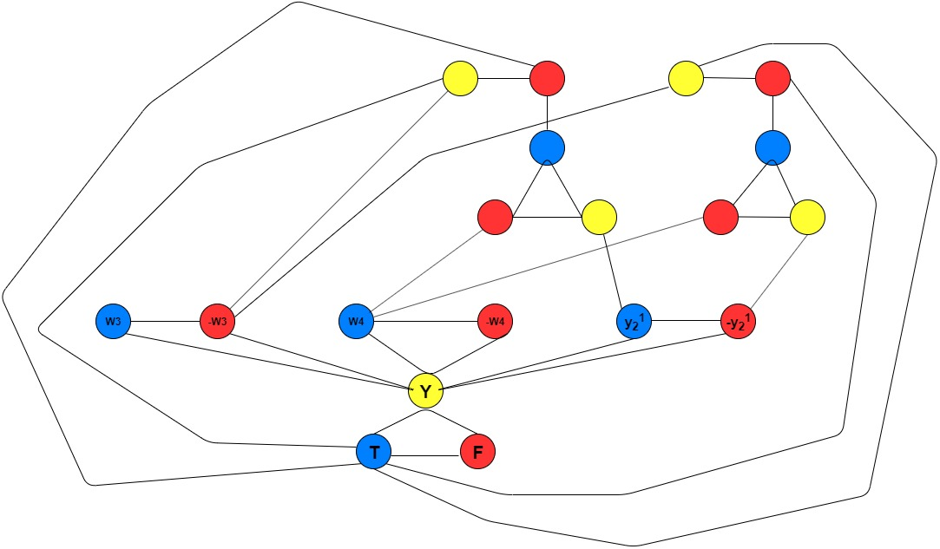

Fig 4

**Part 2: Genetic Algorithms**

**Problem instances**

In this project, you will use the following problem instances to evaluate the performance of your algorithms:

**if the first letter of your surname is in the range A-I inst-0.tsp, inst-13.tsp, and inst-5.tsp**

**Solution:**

A simple genetic algorithm is being applied over the Travelling salesman problem, in order to generate the optimized solution. The solution here is defined as the optimal path the salesman should take in order to cover every city only once and reach the starting point. The genetic algorithm will try to generate the optimal path the salesman can take in order to reduce to path cost.

A genetic algorithm is defined as solving the problem using natural selection. The idea of the genetic algorithm is to produce the optimized result based on the concept of survival of fittest, natural selection and genetics.

The genetic algorithm takes an initial population and performs various operations over it which include fitness calculation, crossover, mutation and survivor selection.



Fig 5

1. **Initial Population (Initial Solution)**

Generation of the initial population is the first step of a genetic algorithm. The members of the initial population can be referred as Chromosomes with each chromosome having a fitness factor associated with it. The fitness of the chromosome defines how good the chromosome in the population.

In case of TSP, the initial population is defined as the list of paths that will be used by the genetic algorithm in order to generate the optimal solution i.e. path with least cost.

Here, two approaches have been used in order to generate the initial population

* Randomly generated population
* Heuristic Approach: Nearest Neighbour Insertion (Choose first city randomly, each city thereafter choose city closest to the last city added to the route and append to the route)

**Randomly generated population:**

1. Generate a list of all the cities.
2. Calculate the length of the list containing all the cities, say n
3. Shuffle the cities inside the list for the n times in order to generate a random city chromosome
4. Repeat step 3 for P times, where P is the size of the population

**Heuristic Approach:**

1. Generate a list of all the cities
2. Select a random city as the starting point
3. Calculate the path cost of all the cities from the randomly selected city
4. Append the city with the least path cost after the city selected in step 2
5. Repeat step 3 and 4 for the city generated in step 4
6. Repeat above steps for P times, where P is the size of the population
7. **Selection**

The selection is the process where the parent chromosomes are selected for mating in order to produce offspring. The offspring are then used to create a new generation.

Here, two approaches have been used in order to generate the solution

* Random Selection
* Stochastic Universal Sampling

In order to perform the selection over the population a mating pool is created from the population over which the selection techniques are applied. The mating pool contain the instance of the population over which various operations are performed in order to create new generation.

**Random Selection:**

1. Generate a mating pool as a copy of the population
2. Randomly select the parent chromosomes from the mating pool
3. The number of parent chromosomes selected depends upon how many parents are required to perform the mating in order to generate the offspring
4. In order to generate two offspring, two parents are randomly selected from the mating pool.
5. The random selection of parents ensures the diversity in the next generation

**Stochastic Universal Sampling:**

In Stochastic Universal Sampling procedure, the parent chromosomes are selected based on fitness value. In case of TSP, the parent with least path cost is the fittest and must have the highest probability of getting selected. The Stochastic universal sampling ensures selection of fitter candidate.

1. Compute the fitness of every individual in the population
2. In case of TSP, there is a need to perform minimisation of each individual fitness in order to get the individual with least path cost selected.
3. Perform Minimisation of fitness:
   1. Get the maximum fitness value from the list of individual fitness
   2. In order to prevent non selection of individuals with maximum fitness, add a token amount of 1 to the maximum fitness value
   3. Subtract the (Maximum fitness + 1) from individual’s fitness
4. Generate the selection probability for individual by dividing the minimized fitness with the sum of minimized fitness
5. Assign every individual a range equal in length to its minimized fitness and the starting point that is after the end point of the previous individual (e.g. first individual 0< I <=0.3, 0.3< II <= 0.5 and so on till the fitness reaches 1)
6. Compute the distance P between successive points: P = F/N; where F is the sum of minimized fitness values and N equal to the population size
7. Generate a random number between 0 and P as the starting point for the ruler. The ruler has n equally spaced points, each P distance apart
8. Select the chromosomes whose range contains a marker

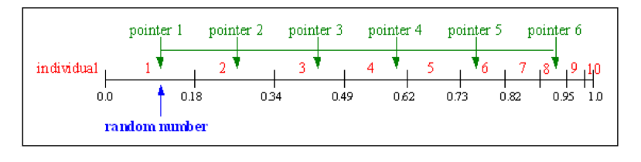 *Reference: Lecture Slides*

Fig 6

**3. Crossover**

The process of selecting 2 individuals (Parents) to obtain two new individuals (the children) is called crossover.

Here we will be looking at two types of crossover techniques with respect to Travelling salesman problem.

* Uniform Crossover
* PMX Crossover

**Uniform crossover (TSP):**

1. Select two parents from the mating pool over which the crossover is to be performed
2. Generate a list of random numbers which will be the position of the genes, ensuring that the genes of the parent at these positions will not change
3. Update the offspring with the genes from alternative parent that are not already present in the offspring in the order they appear
4. This will generate two children.

**Partially Mapped Crossover (PMX):**

1. Select two parents from the mating pool over which the crossover is to be performed
2. Generate random indices, the genes at these indices should be present in the offspring of the alternative parent. Example, if the indices are 2,5 then the offspring A will have genes from Parent B at location 2 ,5. Similarly the offspring B will have genes from Parent A at location 2,5.
3. Create a mapping space for the reversed genes present in the offspring
4. Select the gene from parent to be inserted into the offspring.
5. If the gene is already present in the offspring, use the mapping cycle generated in step 3 to find the appropriate gene
6. This will generate two children.

**4. Mutation**

The process is defined as changing the gene or a set of genes present in the chromosome based on a certain probability called Pm (Mutation Probability) to generate a new chromosome which ensure diversity.

A random number is generated in order to decide if the Mutation in the chromosome is required or not. If the value of the generated random number is greater than Pm then no mutation is performed on the chromosome else the chromosome is mutated.

Here, two approaches have been followed to perform Mutation over a TSP

* Reciprocal Exchange
* Inversion Mutation

**Reciprocal Exchange:**

1. Define a mutation probability Pm in order to perform Mutation
2. If the Pm is greater than the generated random number, then the chromosome undergoes mutation
3. Select two locations in the chromosome that need to be mutated
4. Exchange the genes present at these locations with each other
5. A new mutated individual is generated

**Inversion Mutation:**

1. Define a mutation probability Pm in order to perform Mutation
2. If the Pm is greater than the generated random number, then the chromosome undergoes mutation
3. Select a range of indices in the chromosome
4. Reverse the order of the cities in that range, like 5,3,2,8 will be changed to 8,2,3,5
5. A new mutated individual is generated

**Evaluation of Genetic Algorithm for Travelling Salesman Problem:**

The call to the Genetic Algorithm is made by passing the below set of parameters.

The Parameters are mentioned in order they appear in the call

Parameter List:

1. Filename

2. Population Size

3. Mutation Rate

4. Maximum Iterations

5. Initial Solution = {0: Random, 1: Heuristic}

6. Selection/Mating Pool = {0: Random, 1: Stochastic}

7. Crossover type = {0: Uniform Crossover, 1: PMX Crossover}

8. Mutation Type = {0: Inversion Exchange, 1: Reciprocal Exchange}

The below runs have been performed with

* Population Size = 100
* Mutation Rate = 0.1
* Max. Iterations = 500

**1.1. Problem Instance: inst-0.tsp**

|  |  |  |  |  |
| --- | --- | --- | --- | --- |
| **Configuration** | **Initial Solution** | **Crossover** | **Mutation** | **Selection** |
| 1 | Random | Uniform Crossover | Inversion Mutation | Random Selection |

**Result:**

ga = BasicTSP(inst-0.tsp, 100, 0.1, 500, 0, 0, 0, 0) => Configuration 1   
Best initial sol: 22660915.870452467  
iteration: 1 best: 22575805.310351096  
iteration: 2 best: 22384124.58659526  
iteration: 2 best: 21879392.23622143  
iteration: 146 best: 21863425.109339617  
iteration: 223 best: 21834213.447653532  
iteration: 377 best: 21825705.565501373  
Total iterations: 500  
Best Solution: 21825705.565501373

|  |  |  |  |  |
| --- | --- | --- | --- | --- |
| **Configuration** | **Initial Solution** | **Crossover** | **Mutation** | **Selection** |
| 2 | Random | PMX Crossover | Reciprocal Exchange | Random Selection |

**Result:**

ga = BasicTSP(inst-0.tsp, 100, 0.1, 500, 0, 0, 1, 1) => Configuration 2   
Best initial sol: 22847093.082295213  
iteration: 1 best: 22808902.487161294  
iteration: 1 best: 22755466.652624987  
iteration: 8 best: 22596327.39771201  
iteration: 8 best: 21913952.422215622  
iteration: 118 best: 21788078.984594848  
iteration: 118 best: 21674639.242117763  
iteration: 216 best: 21663320.33557625  
Total iterations: 500  
Best Solution: 21663320.33557625

|  |  |  |  |  |
| --- | --- | --- | --- | --- |
| **Configuration** | **Initial Solution** | **Crossover** | **Mutation** | **Selection** |
| 3 | Random | Uniform Crossover | Reciprocal Exchange | Stochastic Universal Sampling |

**Result:**

ga = BasicTSP(inst-0.tsp, 100, 0.1, 500, 0, 1, 0, 1) => Configuration 3   
Best initial sol: 22886068.64860538  
iteration: 0 best: 22516461.110894207  
iteration: 1 best: 22453699.268370792  
iteration: 2 best: 22402856.100089893  
iteration: 3 best: 22328000.83147648  
iteration: 6 best: 22289146.293337077  
iteration: 12 best: 22157634.46091007  
iteration: 14 best: 22111604.861584924  
iteration: 14 best: 22111537.444386072  
iteration: 17 best: 22092721.274437405  
iteration: 18 best: 22012149.77696025  
iteration: 21 best: 21732993.8092514  
iteration: 43 best: 21237337.365332413  
iteration: 70 best: 21183760.479646575  
iteration: 130 best: 21123242.82324797  
iteration: 131 best: 21082321.30993389  
iteration: 150 best: 21024091.51920423  
iteration: 168 best: 20931573.058328267  
iteration: 173 best: 20777675.48475249  
iteration: 177 best: 20631727.670333944  
iteration: 189 best: 20504870.861805994  
iteration: 199 best: 20394066.173724215  
iteration: 214 best: 20126734.232214708  
iteration: 225 best: 19790874.29048226  
iteration: 248 best: 19652598.86416818  
iteration: 255 best: 19337298.78953982  
iteration: 258 best: 19044557.56750981  
iteration: 280 best: 18754220.92965149  
iteration: 290 best: 18517291.30118629  
iteration: 302 best: 18503786.43576676  
iteration: 333 best: 18212514.85577832  
iteration: 349 best: 18193966.64865517  
iteration: 352 best: 17878371.623039637  
iteration: 373 best: 17659689.942933306  
iteration: 387 best: 17649688.743698742  
iteration: 388 best: 17444678.92116526  
iteration: 395 best: 17375223.49338467  
iteration: 403 best: 17357293.32798947  
iteration: 403 best: 17059174.123856038  
iteration: 404 best: 16860576.46273848  
iteration: 408 best: 16594199.240656896  
iteration: 438 best: 16451141.700147297  
iteration: 442 best: 15991990.434037982  
iteration: 459 best: 15972203.155799385  
iteration: 462 best: 15781534.15930021  
iteration: 477 best: 15744810.325517647  
iteration: 492 best: 15736331.57344456  
iteration: 492 best: 15542988.732507162  
Total iterations: 500  
Best Solution: 15542988.732507162

|  |  |  |  |  |
| --- | --- | --- | --- | --- |
| **Configuration** | **Initial Solution** | **Crossover** | **Mutation** | **Selection** |
| 4 | Random | PMX Crossover | Reciprocal Exchange | Stochastic Universal Sampling |

**Result:**

ga = BasicTSP(inst-0.tsp, 100, 0.1, 500, 0, 1, 1, 1) => Configuration 4   
Best initial sol: 23012973.680887677  
iteration: 0 best: 22776783.25554856  
iteration: 0 best: 22319684.403304577  
iteration: 8 best: 21767351.0706664  
Total iterations: 500  
Best Solution: 21767351.0706664

|  |  |  |  |  |
| --- | --- | --- | --- | --- |
| **Configuration** | **Initial Solution** | **Crossover** | **Mutation** | **Selection** |
| 5 | Random | PMX Crossover | Inversion Mutation | Stochastic Universal Sampling |

**Result:**

ga = BasicTSP(inst-0.tsp, 100, 0.1, 500, 0, 1, 1, 0) => Configuration 5   
Best initial sol: 22333309.479640435  
iteration: 6 best: 22308523.586315416  
iteration: 9 best: 21882983.86831303  
Total iterations: 500  
Best Solution: 21882983.86831303

|  |  |  |  |  |
| --- | --- | --- | --- | --- |
| **Configuration** | **Initial Solution** | **Crossover** | **Mutation** | **Selection** |
| 6 | Random | Uniform Crossover | Inversion Mutation | Stochastic Universal Sampling |

**Result:**

ga = BasicTSP(inst-0.tsp, 100, 0.1, 500, 0, 1, 0, 0) => Configuration 6   
Best initial sol: 22923572.532410886  
iteration: 1 best: 22899676.43871158  
iteration: 2 best: 22895660.77738882  
iteration: 3 best: 22751499.327354733  
iteration: 4 best: 22542709.409422938  
iteration: 5 best: 21917423.540461235  
iteration: 41 best: 21702575.285882667  
iteration: 78 best: 21688546.45471455  
iteration: 79 best: 21586688.29835017  
iteration: 99 best: 21440111.19600911  
iteration: 102 best: 21082362.514791094  
iteration: 111 best: 20772797.127014495  
iteration: 156 best: 20647332.288178287  
iteration: 157 best: 20259170.888847996  
iteration: 165 best: 20187322.1262012  
iteration: 171 best: 20085942.10267234  
iteration: 173 best: 20065326.86047129  
iteration: 173 best: 19525736.75131744  
iteration: 348 best: 19377748.041368447  
iteration: 464 best: 19330987.525509275  
iteration: 471 best: 19241970.27061434  
iteration: 483 best: 19209204.63195392  
iteration: 494 best: 19199746.41837105  
iteration: 499 best: 18552891.310645808  
Total iterations: 500  
Best Solution: 18552891.310645808

|  |  |  |  |  |
| --- | --- | --- | --- | --- |
| **Configuration** | **Initial Solution** | **Crossover** | **Mutation** | **Selection** |
| 7 | Heuristic | PMX Crossover | Reciprocal Exchange | Stochastic Universal Sampling |

**Result:**

ga = BasicTSP(inst-0.tsp, 100, 0.1, 500, 1, 1, 1, 1) => Configuration 7   
Best initial sol: 4146917.8682248485  
Total iterations: 500  
Best Solution: 4146917.8682248485

|  |  |  |  |  |
| --- | --- | --- | --- | --- |
| **Configuration** | **Initial Solution** | **Crossover** | **Mutation** | **Selection** |
| 8 | Heuristic | Uniform Crossover | Inversion Mutation | Stochastic Universal Sampling |

**Result:**

ga = BasicTSP(inst-0.tsp, 100, 0.1, 500, 1, 1, 0, 0) => Configuration 8   
Best initial sol: 4126111.863870551  
Total iterations: 500  
Best Solution: 4126111.863870551

**1.2. Result Analysis: inst-0.tsp**

It can be observed from the output that different configurations lead to a different optimized path cost.

The above test was performed with two set of initial population Random and Heuristic.

In configuration from 1 to 6, the initial population selection was Random which generated the best initial solution i.e. the path cost on the population generated randomly**.** The genetic algorithm was run over this initial path solution with a combination of various selection, crossover and Mutation operators. With the Population Size =100, Mutation Probability = 0.1 and Iterations = 500.

**Best Result**:

The Genetic Algorithm performs extremely well in case of Configuration 3 (Random Initial Population, Stochastic selection, Uniform Crossover, Reciprocal Exchange Mutation).

* The path cost is reduced in a well-informed pattern, providing the optimized path cost as: **15542988.732507162**
* Over 500 iterations, the path cost is continuously reduced as it can be seen from the pattern and a reduction of **32.08 %** in path cost is observed
* The random initial population is passed to a Stochastic Selection and a resulting pool is populations of individuals along with their fitness, which ensures that the individual with better fitness (least path cost) has more chances to get selected over the other.
* Two parents are selected from this pool and are mated in order to produce two offspring.
* The two offspring are passed to a Reciprocal Exchange mutation function and based on the mutation probability, the offspring are mutated.
* The offspring are then added to the population set in order to generate a new population over which the genetic algorithm steps are reapplied
* The process is continued for 500 iterations and the best of all the path cost is returned.

**Result comparison over different configurations**

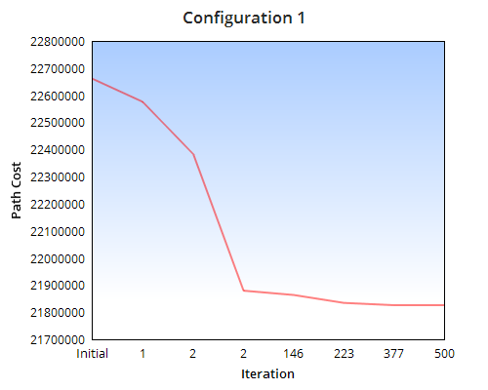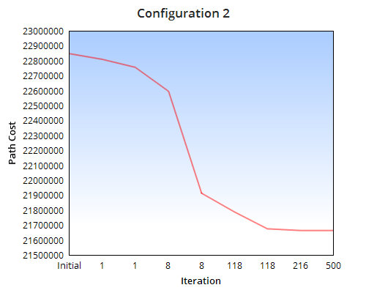

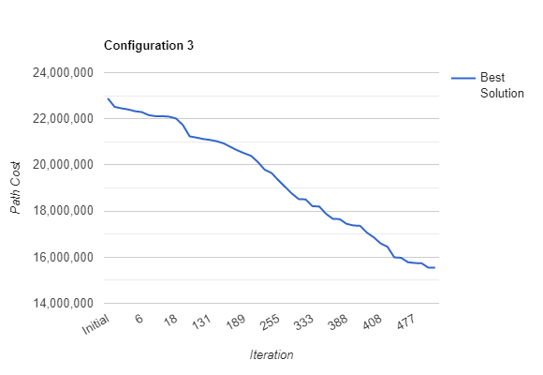

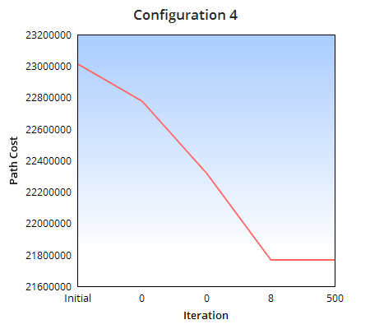 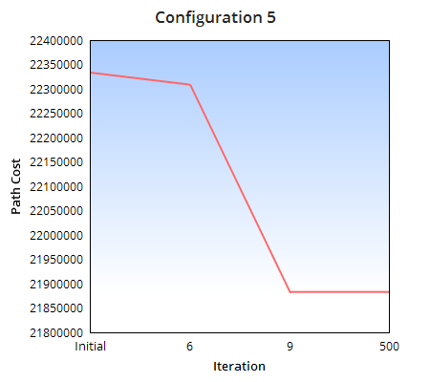

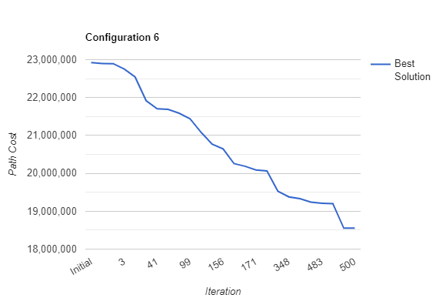

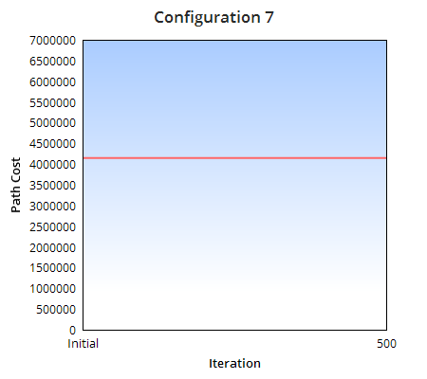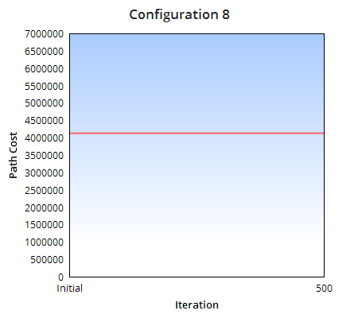

Fig 7

**Conclusion:**

1. It can be concluded from the above line graphs that the genetic algorithm stands out in case of configuration 3, followed by configuration 6. Therefore, the configuration 3 i.e. A random initial solution on which stochastic universal sampling is performed to select parents followed by generating offspring using Uniform crossover and Reciprocal exchange with a mutation rate of 0.1 works well in optimizing the path for TSP.

|  |  |  |  |  |  |  |
| --- | --- | --- | --- | --- | --- | --- |
| **Configuration** | **Initial Solution** | **Crossover** | **Mutation** | **Selection** | **Best Initial Solution** | **Best Final Solution** |
| 3 | Random | Uniform Crossover | Reciprocal Exchange | Stochastic Universal Sampling | 22886068 | 15542988 |
| 6 | Random | Uniform Crossover | Inversion Mutation | Stochastic Universal Sampling | 22923572 | 18552891 |

1. Configuration 1 and 2 perform decent compared to Configuration 4 and 5 as it can be observed that there in config. 4 ,5 the new generation generated is not able to provide a better solution in most of the iterations. In conf. 1,2 the same behaviour is obtained but there is good reduction in path cost compared to config 4,5. A reduction of average 5% is observed for config 1,2 compared to a reduction in path cost of average 3.7% for config. 4,5
2. Configuration 7 and 8 which use a Heuristic approach to generate the initial solution are not able to get any better solution from the initial solution which is the optimal path cost generated using K nearest neighbour. There is a need to verify the configuration by changing the Mutation Rate, Population size and initial population generation to see if the genetic algorithm can return a better solution

**2.1. Problem Instance: inst-13.tsp**

|  |  |  |  |  |
| --- | --- | --- | --- | --- |
| **Configuration** | **Initial Solution** | **Crossover** | **Mutation** | **Selection** |
| 1 | Random | Uniform Crossover | Inversion Mutation | Random Selection |

**Result:**

ga = BasicTSP(inst-13.tsp, 100, 0.1, 500, 0, 0, 0, 0) => Configuration 1   
Best initial sol: 116982960.19802372  
iteration: 0 best: 116081484.29379007  
iteration: 1 best: 113716602.58195189  
iteration: 5 best: 112545962.92544843  
iteration: 21 best: 111181108.27228457  
iteration: 70 best: 111094744.1823467  
iteration: 80 best: 110978374.39712472  
iteration: 126 best: 109830572.27319342  
iteration: 207 best: 109318666.18771437  
iteration: 258 best: 108920452.2622373  
iteration: 314 best: 108449794.10797097  
Total iterations: 500  
Best Solution: 108449794.10797097

|  |  |  |  |  |
| --- | --- | --- | --- | --- |
| **Configuration** | **Initial Solution** | **Crossover** | **Mutation** | **Selection** |
| 2 | Random | PMX Crossover | Reciprocal Exchange | Random Selection |

**Result:**

ga = BasicTSP(inst-13.tsp, 100, 0.1, 500, 0, 0, 1, 1) => Configuration 2   
Best initial sol: 111901722.68610172  
iteration: 0 best: 111413051.9177431  
iteration: 28 best: 111271743.55565692  
iteration: 28 best: 111049791.997235  
iteration: 35 best: 108620390.32709691  
iteration: 173 best: 107201307.29585366  
Total iterations: 500  
Best Solution: 107201307.29585366

|  |  |  |  |  |
| --- | --- | --- | --- | --- |
| **Configuration** | **Initial Solution** | **Crossover** | **Mutation** | **Selection** |
| 3 | Random | Uniform Crossover | Reciprocal Exchange | Stochastic Universal Sampling |

**Result:**

ga = BasicTSP(inst-13.tsp, 100, 0.1, 500, 0, 1, 0, 1) => Configuration 3   
Best initial sol: 112590906.77819058  
iteration: 5 best: 112508104.85055391  
iteration: 19 best: 109298777.93804802  
iteration: 48 best: 108777815.45410454  
iteration: 48 best: 107284526.45226043  
iteration: 60 best: 107102527.25304906  
iteration: 68 best: 106379995.30998725  
iteration: 76 best: 106351272.25621435  
iteration: 78 best: 106215308.92814976  
iteration: 84 best: 105698905.9248304  
iteration: 90 best: 105408550.60845655  
iteration: 93 best: 104145566.84567013  
iteration: 96 best: 102105032.1843735  
iteration: 110 best: 97154605.59298928  
iteration: 141 best: 95720158.74691135  
iteration: 144 best: 93815614.74092367  
iteration: 145 best: 92435593.00921442  
iteration: 145 best: 88513521.87378135  
iteration: 170 best: 88150969.45838259  
iteration: 174 best: 84265746.75481679  
iteration: 189 best: 82988225.80134173  
iteration: 195 best: 82469743.85976893  
iteration: 199 best: 82270755.9403867  
iteration: 200 best: 81552895.15509084  
iteration: 200 best: 79883361.82864763  
iteration: 201 best: 79070031.23156731  
iteration: 201 best: 78408290.83528735  
iteration: 202 best: 77921969.72726554  
iteration: 219 best: 77582067.17504564  
iteration: 220 best: 77178124.92693746  
iteration: 223 best: 75923659.11206605  
iteration: 224 best: 75360324.11322674  
iteration: 228 best: 72735633.65955727  
iteration: 238 best: 72531833.11924373  
iteration: 240 best: 70120561.42378011  
iteration: 248 best: 69251665.12891233  
iteration: 248 best: 67252892.85487972  
iteration: 251 best: 66647100.49607952  
iteration: 258 best: 66588628.98032125  
iteration: 260 best: 66395267.09575622  
iteration: 265 best: 63789770.9579033  
iteration: 279 best: 62453533.17267204  
iteration: 282 best: 61084948.518785104  
iteration: 286 best: 60951250.60431431  
iteration: 315 best: 59704421.28586427  
iteration: 316 best: 59698021.690774314  
iteration: 353 best: 58842839.60798073  
iteration: 410 best: 56823710.12785909  
iteration: 415 best: 56501406.61181191  
iteration: 416 best: 56205406.53880962  
iteration: 417 best: 55775500.37989149  
iteration: 428 best: 55078363.15105846  
iteration: 441 best: 54070762.73053891  
iteration: 446 best: 53860293.86936242  
iteration: 448 best: 52097863.65657239  
iteration: 449 best: 51563917.244559236  
iteration: 486 best: 51255710.393093936  
iteration: 498 best: 49471728.943859056  
Total iterations: 500  
Best Solution: 49471728.943859056

|  |  |  |  |  |
| --- | --- | --- | --- | --- |
| **Configuration** | **Initial Solution** | **Crossover** | **Mutation** | **Selection** |
| 4 | Random | PMX Crossover | Reciprocal Exchange | Stochastic Universal Sampling |

**Result:**

ga = BasicTSP(inst-13.tsp, 100, 0.1, 500, 0, 1, 1, 1) => Configuration 4   
Best initial sol: 114378273.11260504  
iteration: 0 best: 113321459.2664534  
iteration: 2 best: 112100203.80794685  
iteration: 9 best: 111952066.05386105  
iteration: 38 best: 111466042.14971489  
Total iterations: 500  
Best Solution: 111466042.14971489

|  |  |  |  |  |
| --- | --- | --- | --- | --- |
| **Configuration** | **Initial Solution** | **Crossover** | **Mutation** | **Selection** |
| 5 | Random | PMX Crossover | Inversion Mutation | Stochastic Universal Sampling |

**Result:**

ga = BasicTSP(inst-13.tsp, 100, 0.1, 500, 0, 1, 1, 0) => Configuration 5   
Best initial sol: 115010857.021496  
iteration: 0 best: 112118328.39548004  
iteration: 6 best: 112114998.83220676  
iteration: 6 best: 110525638.18037358  
Total iterations: 500  
Best Solution: 110525638.18037358

|  |  |  |  |  |
| --- | --- | --- | --- | --- |
| **Configuration** | **Initial Solution** | **Crossover** | **Mutation** | **Selection** |
| 6 | Random | Uniform Crossover | Inversion Mutation | Stochastic Universal Sampling |

**Result:**

ga = BasicTSP(inst-13.tsp, 100, 0.1, 500, 0, 1, 0, 0) => Configuration 6   
Best initial sol: 115424898.38681377  
iteration: 0 best: 111661835.30078483  
iteration: 4 best: 109325661.45548317  
iteration: 5 best: 109264218.3999125  
iteration: 49 best: 107329471.50869654  
iteration: 56 best: 106488201.10893932  
iteration: 68 best: 105966877.12718844  
iteration: 70 best: 105748716.1297273  
iteration: 148 best: 103790765.42840298  
iteration: 190 best: 103771939.91598469  
iteration: 202 best: 103739449.93491232  
iteration: 213 best: 103594150.5415196  
iteration: 242 best: 103553339.00026456  
iteration: 339 best: 102522002.44158483  
iteration: 346 best: 102278996.83068873  
iteration: 377 best: 100579129.24414167  
iteration: 401 best: 100172858.9526735  
iteration: 402 best: 97717739.91825423  
iteration: 427 best: 95898928.56502724  
Total iterations: 500  
Best Solution: 95898928.56502724

|  |  |  |  |  |
| --- | --- | --- | --- | --- |
| **Configuration** | **Initial Solution** | **Crossover** | **Mutation** | **Selection** |
| 7 | Heuristic | PMX Crossover | Reciprocal Exchange | Stochastic Universal Sampling |

**Result:**

ga = BasicTSP(inst-13.tsp, 100, 0.1, 500, 1, 1, 1, 1) => Configuration 7   
Best initial sol: 7203070.735067  
Total iterations: 500  
Best Solution: 7203070.735067

|  |  |  |  |  |
| --- | --- | --- | --- | --- |
| **Configuration** | **Initial Solution** | **Crossover** | **Mutation** | **Selection** |
| 8 | Heuristic | Uniform Crossover | Inversion Mutation | Stochastic Universal Sampling |

**Result:**

ga = BasicTSP(inst-13.tsp, 100, 0.1, 500, 1, 1, 0, 0) => Configuration 8   
Best initial sol: 7218941.1220835615  
Total iterations: 500  
Best Solution: 7218941.1220835615

**2.2. Result Analysis: inst-13.tsp**

It can be observed from the output that different configurations lead to a different optimized path cost.

The above test was performed with two set of initial population Random and Heuristic.

In configuration from 1 to 6, the initial population selection was Random which generated the best initial solution i.e. the path cost on the population generated randomly**.** The genetic algorithm was run over this initial path solution with a combination of various selection, crossover and Mutation operators. With the Population Size =100, Mutation Probability = 0.1 and Iterations = 500.

**Best Result**:

The Genetic Algorithm performs extremely well in case of Configuration 3 (Random Initial Population, Stochastic selection, Uniform Crossover, Reciprocal Exchange Mutation).

* The path cost is reduced in a well-informed pattern, providing the optimized path cost as: **49471728.943859056**
* Over 500 iterations, the path cost is continuously reduced as it can be seen from the pattern and a reduction of **56.06 %** in path cost is observed
* The random initial population is passed to a Stochastic Selection and a resulting pool is populations of individuals along with their fitness, which ensures that the individual with better fitness (least path cost, used Minimization) has more chances to get selected over the other.
* Two parents are selected from this pool and are mated in order to produce two offspring.
* The two offspring are passed to a Reciprocal Exchange mutation function and based on the mutation probability, the offspring are mutated.
* The offspring are then added to the population set in order to generate a new population over which the genetic algorithm steps are reapplied
* The process is continued for 500 iterations and the best of all the path cost is returned.

**Result comparison over different configurations**

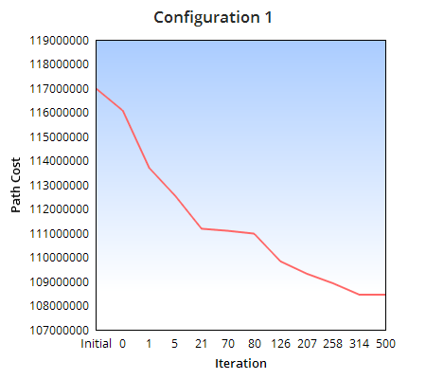 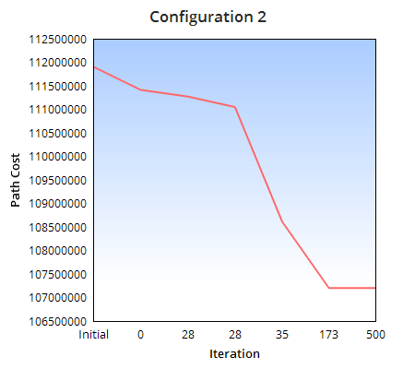

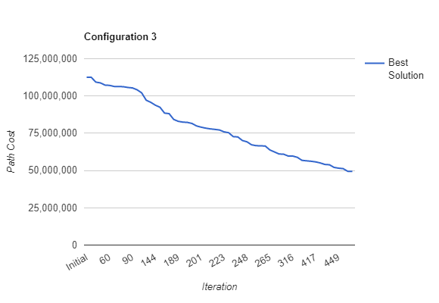

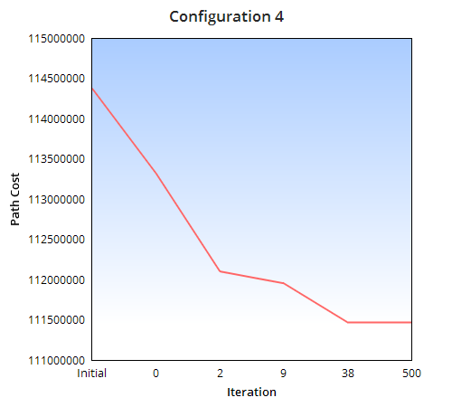 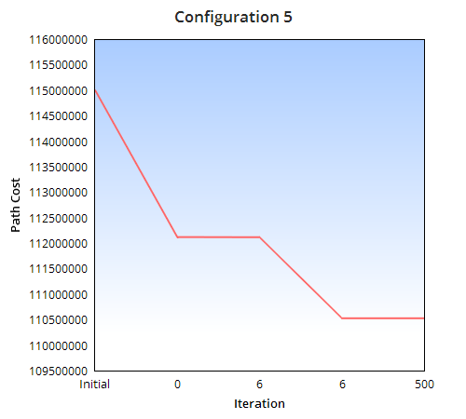

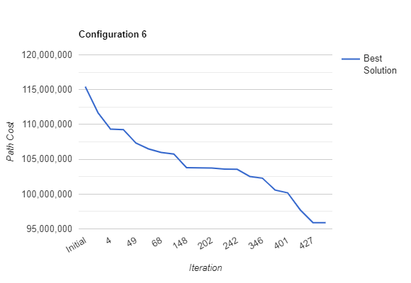

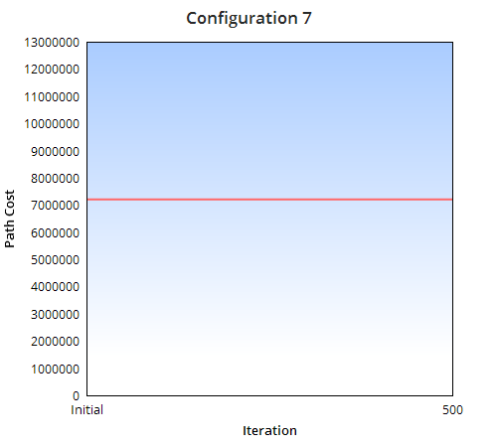 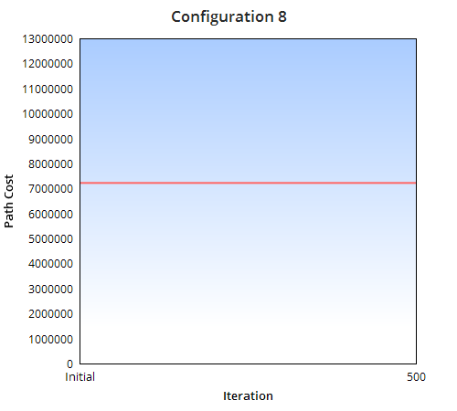

Fig 8

**Conclusion:**

1. It can be concluded from the above line graphs that the genetic algorithm stands out in case of configuration 3, followed by configuration 6. Therefore, the configuration 3 i.e. A random initial solution on which stochastic universal sampling is performed to select parents followed by generating offspring using Uniform crossover and Reciprocal Exchange with a mutation rate of 0.1 works well in optimizing the path for TSP.

|  |  |  |  |  |  |  |
| --- | --- | --- | --- | --- | --- | --- |
| **Configuration** | **Initial Solution** | **Crossover** | **Mutation** | **Selection** | **Best Initial Solution** | **Best Final Solution** |
| 3 | Random | Uniform Crossover | Reciprocal Exchange | Stochastic Universal Sampling | 112590906 | 49471728 |
| 6 | Random | Uniform Crossover | Inversion Mutation | Stochastic Universal Sampling | 115424898 | 95898928 |

1. Configuration 1 and 2 perform decent compared to Configuration 4 and 5 as it can be observed that there in config. 4,5 the new generation generated is not able to provide a better solution in most of the iterations. In conf. 1,2 the same behaviour is obtained but there is good reduction in path cost (**average 5.7 %**) compared to config 4,5 (**average 3.2%**).
2. Configuration 7 and 8 which use a Heuristic approach to generate the initial solution are not able to get any better solution from the initial solution which is the optimal path cost generated using K nearest neighbour. There is a need to verify the configuration by changing the Mutation Rate, Population size and initial population generation to see if the genetic algorithm can return a better solution

**3.1. Problem Instance: inst-5.tsp**

|  |  |  |  |  |
| --- | --- | --- | --- | --- |
| **Configuration** | **Initial Solution** | **Crossover** | **Mutation** | **Selection** |
| 1 | Random | Uniform Crossover | Inversion Mutation | Random Selection |

**Result:**

ga = BasicTSP(inst-5.tsp, 100, 0.1, 500, 0, 0, 0, 0) => Configuration 1   
Best initial sol: 442292086.7272037  
iteration: 0 best: 439174047.4337871  
iteration: 2 best: 436389032.27438384  
iteration: 4 best: 430254778.7319146  
iteration: 45 best: 427614956.43884045  
iteration: 123 best: 425544615.39597756  
iteration: 207 best: 423773574.8426651  
Total iterations: 500  
Best Solution: 423773574.8426651

|  |  |  |  |  |
| --- | --- | --- | --- | --- |
| **Configuration** | **Initial Solution** | **Crossover** | **Mutation** | **Selection** |
| 2 | Random | PMX Crossover | Reciprocal Exchange | Random Selection |

**Result:**

ga = BasicTSP(inst-5.tsp, 100, 0.1, 500, 0, 0, 1, 1) => Configuration 2   
Best initial sol: 442958144.7820282  
iteration: 0 best: 442542889.3332863  
iteration: 0 best: 440716707.42196465  
iteration: 2 best: 439794042.1214025  
iteration: 5 best: 438570204.4219845  
iteration: 8 best: 436621869.11033696  
iteration: 9 best: 435124391.81678957  
iteration: 9 best: 431355177.69057953  
iteration: 10 best: 430554217.5523967  
iteration: 43 best: 426575787.1800647  
iteration: 310 best: 425542753.5636455  
Total iterations: 500  
Best Solution: 425542753.5636455

|  |  |  |  |  |
| --- | --- | --- | --- | --- |
| **Configuration** | **Initial Solution** | **Crossover** | **Mutation** | **Selection** |
| 3 | Random | Uniform Crossover | Reciprocal Exchange | Stochastic Universal Sampling |

**Result:**

ga = BasicTSP(inst-5.tsp, 100, 0.1, 500, 0, 1, 0, 1) => Configuration 3   
Best initial sol: 439726119.60478437  
iteration: 0 best: 439674983.3052773  
iteration: 1 best: 435456703.0402727  
iteration: 3 best: 435184494.48711264  
iteration: 10 best: 434562439.29797435  
iteration: 14 best: 433662725.33515394  
iteration: 19 best: 431387143.8598588  
iteration: 23 best: 429096811.0204498  
iteration: 44 best: 427919827.7034029  
iteration: 53 best: 426819848.93294865  
iteration: 56 best: 426126107.6228172  
iteration: 63 best: 420208822.2954254  
iteration: 110 best: 419779609.2447534  
iteration: 115 best: 418481624.5405844  
iteration: 124 best: 413388097.42137337  
iteration: 143 best: 406835738.52725816  
iteration: 231 best: 406266631.4375808  
iteration: 278 best: 403793315.6684574  
iteration: 286 best: 402130579.8687609  
iteration: 286 best: 401164197.36988944  
iteration: 287 best: 396091603.0758568  
iteration: 363 best: 395210722.21768796  
iteration: 364 best: 394971493.79898924  
iteration: 377 best: 394311461.17771  
iteration: 379 best: 393480813.84330326  
iteration: 388 best: 390420739.3523249  
iteration: 405 best: 389841128.0034549  
iteration: 486 best: 388121895.97890097  
iteration: 496 best: 385551975.4523037  
Total iterations: 500  
Best Solution: 385551975.4523037

|  |  |  |  |  |
| --- | --- | --- | --- | --- |
| **Configuration** | **Initial Solution** | **Crossover** | **Mutation** | **Selection** |
| 4 | Random | PMX Crossover | Reciprocal Exchange | Stochastic Universal Sampling |

**Result:**

ga = BasicTSP(inst-5.tsp, 100, 0.1, 500, 0, 1, 1, 1) => Configuration 4   
Best initial sol: 438227237.3938074  
iteration: 1 best: 436300160.0689194  
iteration: 8 best: 435380110.93164396  
iteration: 8 best: 425406560.95473903  
Total iterations: 500  
Best Solution: 425406560.95473903

|  |  |  |  |  |
| --- | --- | --- | --- | --- |
| **Configuration** | **Initial Solution** | **Crossover** | **Mutation** | **Selection** |
| 5 | Random | PMX Crossover | Inversion Mutation | Stochastic Universal Sampling |

**Result:**

ga = BasicTSP(inst-5.tsp, 100, 0.1, 500, 0, 1, 1, 0) => Configuration 5   
Best initial sol: 439916934.95398176  
iteration: 1 best: 439868613.75613517  
iteration: 1 best: 437826467.3743276  
iteration: 1 best: 437006985.30824  
iteration: 3 best: 436137111.6052191  
Total iterations: 500  
Best Solution: 436137111.6052191

|  |  |  |  |  |
| --- | --- | --- | --- | --- |
| **Configuration** | **Initial Solution** | **Crossover** | **Mutation** | **Selection** |
| 6 | Random | Uniform Crossover | Inversion Mutation | Stochastic Universal Sampling |

**Result:**

ga = BasicTSP(inst-5.tsp, 100, 0.1, 500, 0, 1, 0, 0) => Configuration 6   
Best initial sol: 445005130.0223137  
iteration: 0 best: 436280182.3850226  
iteration: 2 best: 430710365.0038706  
iteration: 5 best: 429753375.124218  
iteration: 44 best: 429691648.374963  
iteration: 44 best: 428456272.3099735  
iteration: 126 best: 424578004.86284995  
iteration: 134 best: 424364857.78645515  
iteration: 279 best: 423527580.3027021  
iteration: 302 best: 421403123.12396187  
iteration: 340 best: 420860692.46102035  
iteration: 438 best: 417586951.0033147  
iteration: 441 best: 416149802.49569803  
iteration: 442 best: 414153370.6057604  
Total iterations: 500  
Best Solution: 414153370.6057604

|  |  |  |  |  |
| --- | --- | --- | --- | --- |
| **Configuration** | **Initial Solution** | **Crossover** | **Mutation** | **Selection** |
| 7 | Heuristic | PMX Crossover | Reciprocal Exchange | Stochastic Universal Sampling |

**Result:**

ga = BasicTSP(inst-5.tsp, 100, 0.1, 500, 1, 1, 1, 1) => Configuration 7   
Best initial sol: 12995945.232143892  
Total iterations: 500  
Best Solution: 12995945.232143892

|  |  |  |  |  |
| --- | --- | --- | --- | --- |
| **Configuration** | **Initial Solution** | **Crossover** | **Mutation** | **Selection** |
| 8 | Heuristic | Uniform Crossover | Inversion Mutation | Stochastic Universal Sampling |

**Result:**

ga = BasicTSP(inst-5.tsp, 100, 0.1, 500, 1, 1, 0, 0) => Configuration 8   
Best initial sol: 12995945.232143892  
Total iterations: 500  
Best Solution: 12995945.232143892

**3.2. Result Analysis: inst-5.tsp**

It can be observed from the output that different configurations lead to a different optimized path cost.

The above test was performed with two set of initial population Random and Heuristic.

In configuration from 1 to 6, the initial population selection was Random which generated the best initial solution i.e. the path cost on the population generated randomly**.** The genetic algorithm was run over this initial path solution with a combination of various selection, crossover and Mutation operators. With the Population Size =100, Mutation Probability = 0.1 and Iterations = 500.

**Best Result**:

The Genetic Algorithm performs extremely well in case of Configuration 3 (Random Initial Population, Stochastic selection, Uniform Crossover, Reciprocal Exchange Mutation).

* The path cost is reduced in a well-informed pattern, providing the optimized path cost as: **385551975.4523037**
* Over 500 iterations, the path cost is continuously reduced as it can be seen from the pattern and a reduction of **12.31 %** in path cost is observed
* The random initial population is passed to a Stochastic Selection and a resulting pool is populations of individuals along with their fitness, which ensures that the individual with better fitness (least path cost, used Minimization) has more chances to get selected over the other.
* Two parents are selected from this pool and are mated in order to produce two offspring.
* The two offspring are passed to a Reciprocal Exchange mutation function and based on the mutation probability, the offspring are mutated.
* The offspring are then added to the population set in order to generate a new population over which the genetic algorithm steps are reapplied
* The process is continued for 500 iterations and the best of all the path cost is returned.

**Result comparison over different configurations**

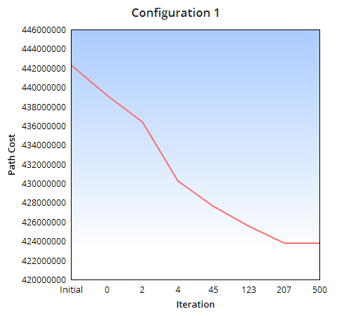 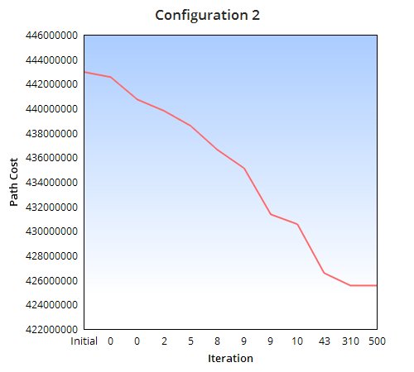

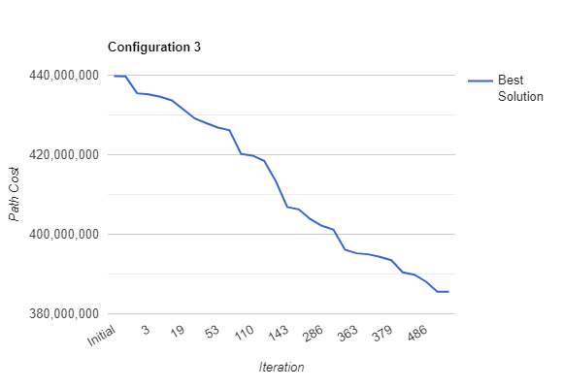

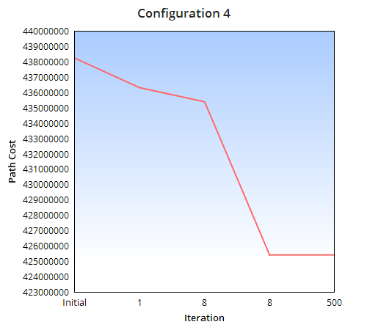 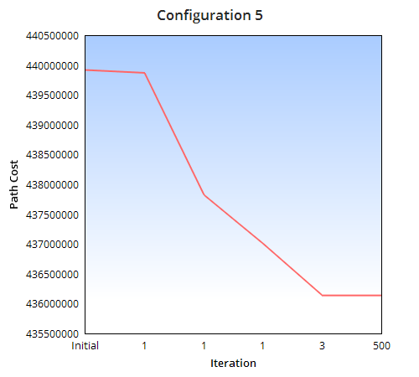

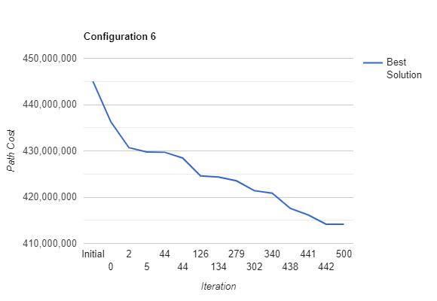

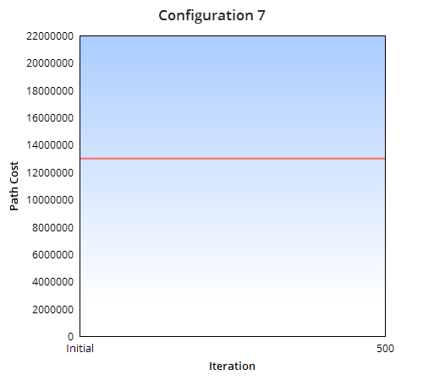 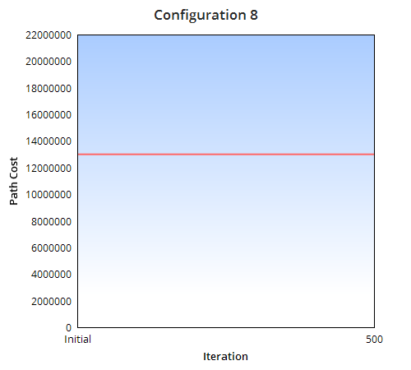

Fig 9

**Conclusion:**

1. It can be concluded from the above line graphs that the genetic algorithm stands out in case of configuration 3, followed by configuration 6. Therefore, the configuration 3 i.e. A random initial solution on which stochastic universal sampling is performed to select parents followed by generating offspring using Uniform crossover and Reciprocal Exchange with a mutation rate of 0.1 works well in optimizing the path for TSP.

|  |  |  |  |  |  |  |
| --- | --- | --- | --- | --- | --- | --- |
| **Configuration** | **Initial Solution** | **Crossover** | **Mutation** | **Selection** | **Best Initial Solution** | **Best Final Solution** |
| 3 | Random | Uniform Crossover | Reciprocal Exchange | Stochastic Universal Sampling | 439726119 | 385551975 |
| 6 | Random | Uniform Crossover | Inversion Mutation | Stochastic Universal Sampling | 445005130 | 414153370 |

1. Configuration 1 and 2 perform decent compared to Configuration 4 and 5 as it can be observed that there in config. 4,5 the new generation generated is not able to provide a better solution in most of the iterations. In conf. 1,2 the same behaviour is obtained but there is good reduction in path cost (**average 4 %**) compared to config 4,5 (**average 1.88%**).
2. Configuration 7 and 8 which use a Heuristic approach to generate the initial solution are not able to get any better solution from the initial solution which is the optimal path cost generated using K nearest neighbour. There is a need to verify the configuration by changing the Mutation Rate, Population size and initial population generation to see if the genetic algorithm can return a better solution

**4. Analysing the overall performance of the Genetic Algorithm**

It can be well drawn from the previous results that the algorithm performs best in case of Configuration 3 i.e. Random Initial Solution with Stochastic Universal Sampling on which uniform crossover and reciprocal exchange mutation is performed followed by Configuration 6 i.e. Random Initial Solution with Stochastic Universal Sampling on which uniform crossover and Inversion mutation is performed.

To analyse the overall performance of the algorithm, we will be running the algorithm with problem instance inst-0.tsp and configuration 3 and 6 for 500 iterations with population size 100 and mutation rate 0.1 for 5 executions with each execution being run for 500 iterations.

|  |
| --- |
| **Configuration 3** |
| **Iteration:** | **Run 1** | **Run 2** | **Run 3** | **Run 4** | **Run 5** | **Mean** | **Median** |
| **Best Fitness:** | 15455157 | 15153924 | 14285366 | 13491097 | 16973901 | **15071889.0** | **15153924.0** |
| **Mean:** | 19089820.11 | 18934967.90 | 18017896.58 | 18078697.11 | 19724978.45 |
| **Median:** | 19064818.00 | 18863455.00 | 17501922.00 | 18135157.00 | 20025632.00 |

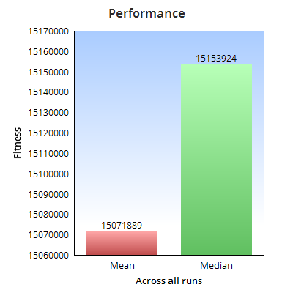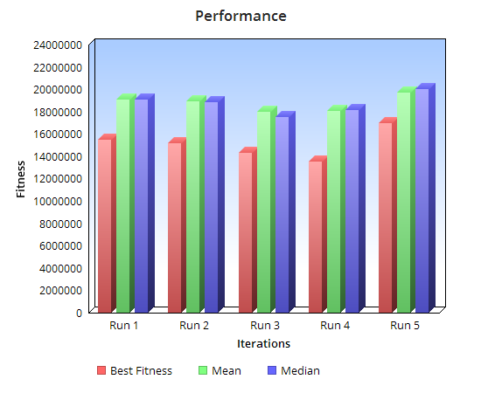

**Conclusion:**

It can be concluded that on average the genetic algorithm with best mean initial solution of

|  |
| --- |
| **Configuration 6** |
| **Iteration:** | **Run 1** | **Run 2** | **Run 3** | **Run 4** | **Run 5** | **Mean** | **Median** |
| **Best Fitness:** | 17983753 | 19266540 | 19637496 | 18352942 | 18189806 | **18686107.4** | **18352942** |
| **Mean:** | 20642087.36 | 20714348.00 | 21031420.27 | 20229969.83 | 20504934.48 |
| **Median:** | 21165917.00 | 21025387.00 | 20900749.00 | 20032761.50 | 20797243.00 |

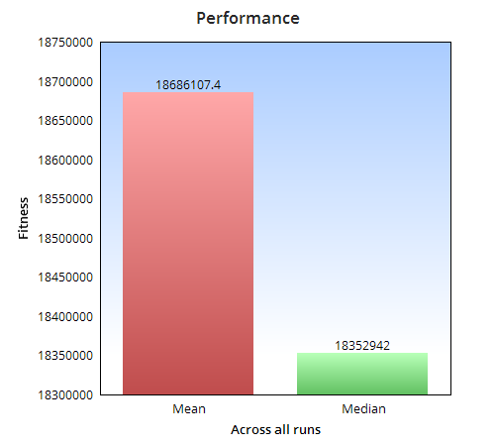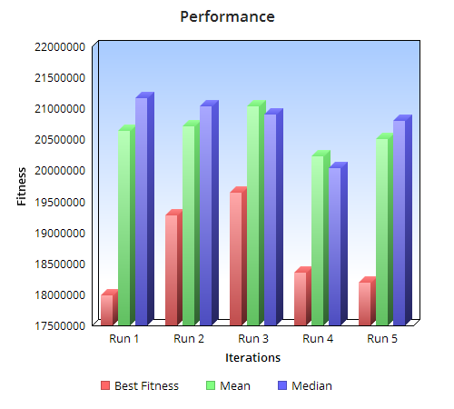

**Conclusion:**

It can be concluded that on average the genetic algorithm with best mean initial solution of

**5. Additional Experimentation of the Genetic Algorithm**

In order to understand the behaviour of the algorithm with a much wider scope, we will be experimenting the impact on the algorithm’s performance by varying the following:

* Population Size
* Mutation Rate

As from the previous performance matrix, the best configuration for the TSP environment we are working on is Configuration 3 and therefore we will be experimenting the above parameters with same configuration and problem instance inst-0.tsp. Please note that the other parameters including initial selection, crossover and number of iterations remain unchanged.

1. **Population Size**

**Mutation Rate: 0.1**

|  |
| --- |
| **Configuration 3** |
| **Population Size:** | **50** | **100** | **200** | **300** | **400** | **500** | **600** | **700** |
| **Best Fitness:** | 16968467 | 15696264 | 12134478 | 11360034 | 11844687 | 12205870 | 11209923 | 11866514 |
| **Mean Fitness:** | 19692012 | 19081233 | 16896535 | 15752571 | 16318932 | 16707477 | 15879129 | 16571079 |

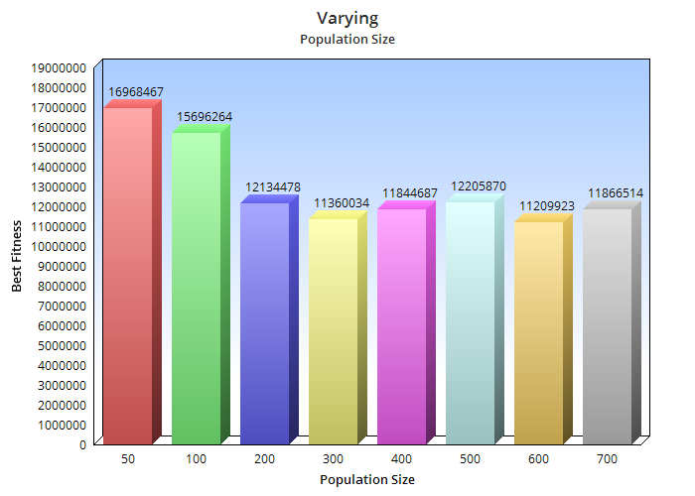

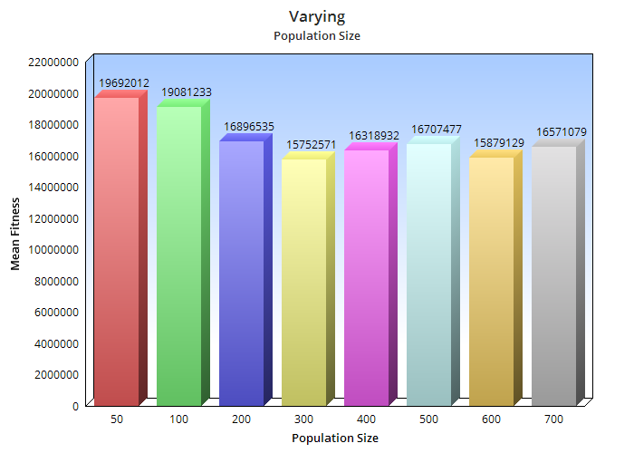

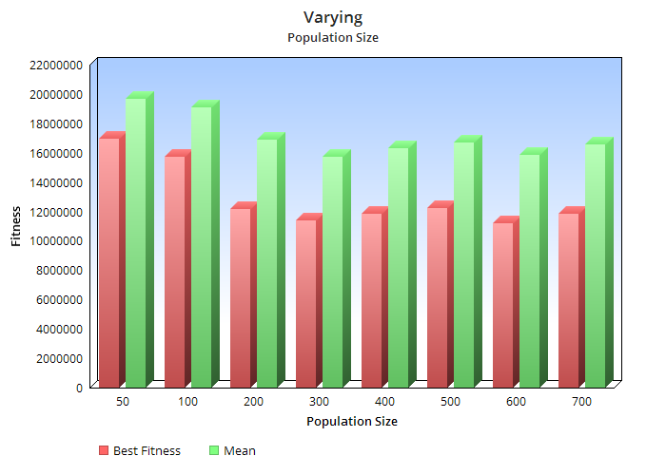

**Conclusion:**

* The best optimal solution is obtained in case of population size = 600, however it can also be concluded that a very near optimal solution is obtained when the population size is half that is 300
* On considering the mean fitness, the best results are obtained when the population is 300.
* On constantly increasing the population size from 50 to 300 a good improvement is seen in the generation of optimal solution
* On further increasing the population the optimal solution was not found of which the genetic algorithm is capable of.
* A very high population size of 700 causes the genetic algorithm to slow down without even producing the best shortest path.
* Therefore, it should be kept in mind that a very high population might not lead to better solution as well as a very low population might not provide diversity in mating pool.
* An optimal population size might be decided with respect to better result and operational time.

1. **Mutation Rate**

**Population Size = 100**

|  |
| --- |
| **Configuration 3** |
| **Mutation Rate:** | **0.009** | **0.01** | **0.05** | **0.10** | **0.50** | **0.90** | **0.99** |
| **Best Fitness:** | 12600539 | 13292195 | 13880773 | 13461701 | 15865444 | 17475067 | 17189750 |
| **Mean Fitness:** | 17060641 | 17520989 | 17632931 | 17825974 | 18988534 | 20239679 | 19944376 |

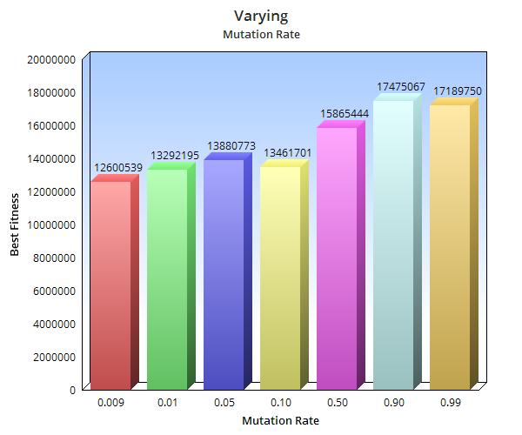

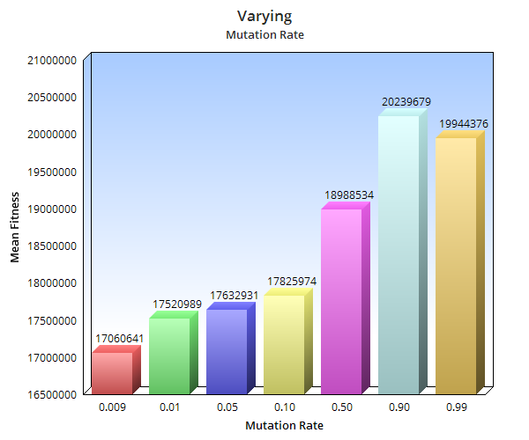

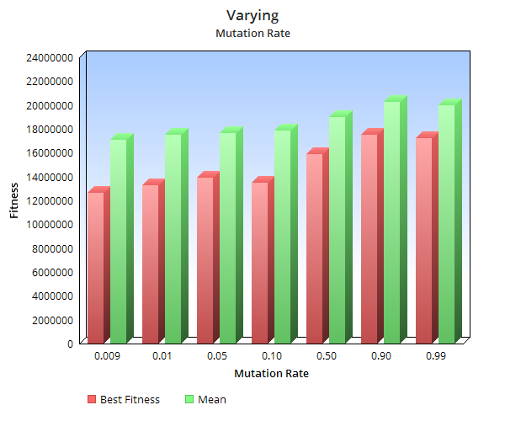

**Conclusion:**

From the above observations with varying the Mutation Rate, it can be concluded that the genetic algorithm performs wells with low mutation probability (Pm).

* As the Pm is reduced the genetic algorithm performs well.
* On increasing the Pm, the genetic algorithm is not able to reach the best optimal solution it is capable of.
* A large Pm, shows that the genetic algorithm gets reduced to a random search
* The best mean fitness is observed in case of Pm 0.009
* In the problem here, specific to TSP, a lower mutation rate preforms well
* A very high mutation rate is not able to maintain the diversity in the population
* Therefore, the mutation rate should be kept such that there is a good balance in diversity of the population

**6. Analysing the Algorithm with best population and mutation rate.**

In the previous section it was observed that the algorithm performs well with population size 300 (when mutation rate = 0.1) and a mutation rate of 0.009 (when population rate = 100). A further experimentation was done to analyse if a much better result that is better optimized path length can be obtained if the best population and mutation rate are combined.

**Result:**

|  |  |  |
| --- | --- | --- |
| **Population** | **Mutation Rate** | **Best Fitness** |
| 100 | 0.1 | 15542988 |
| 300 | 0.1 | 11360034 |
| 100 | 0.009 | 12600539 |
| 300 | 0.009 | 11132780 |

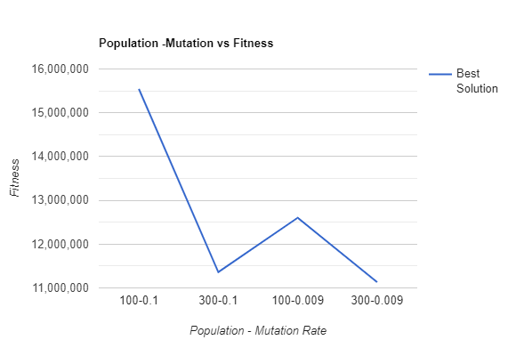

**Conclusion:**

It can be concluded from the above results that the algorithm performs well with a lower mutation rate that is 0.009 and a population of 300 chromosomes.

**7. Experimentation of the Genetic Algorithm with Heuristic Initial Population Selection**

As it can be seen from the above test result, that the initial population generated using heuristic approach is not able to provide any optimized path after running it through the genetic algorithm.

Various trial and error with the population size and mutation rate were tried but still the algorithm was not able to generate any better final solution than the one generated by initial solution

**Approach tried:**

Since the initial population was all generated using the heuristic method, there could have been a possibility of less diversity in the population and therefore making it difficult for the GA to generate any optimal path cost.

In order to test this, the initial population was initialized 50% with heuristic approach and another 50% with random generation of individual. On checking the results, it was observed that the with very less mutation rate(0.005 – 0.009) and population size between 100 to 200 the GA tried reaching to the best initial solution but then resulted in population convergence.

The best initial solution was 3992001.97 , the GA with the above changes was able to find a path cost nearly 4000000 but after that lead to convergence.